# Task23:

# 1.Employee Table:

### Employee table created

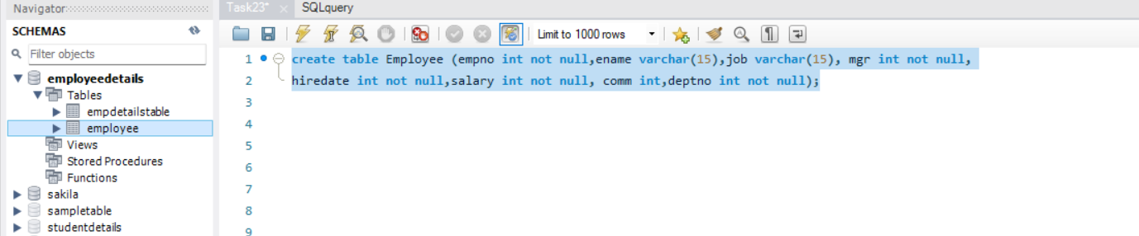



One row inserted

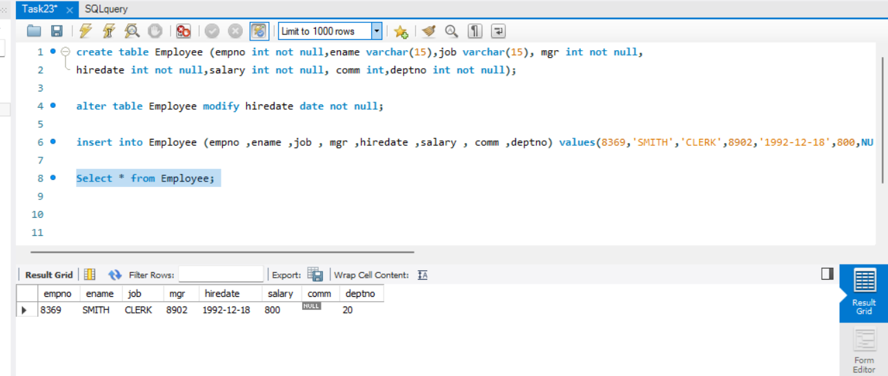

All other rows are inserted

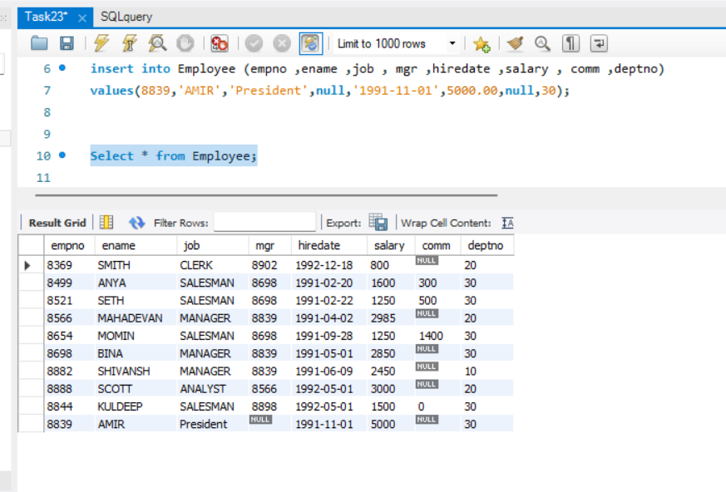

A. Display ename and salary of employee where salary greater than or equal to 2200.

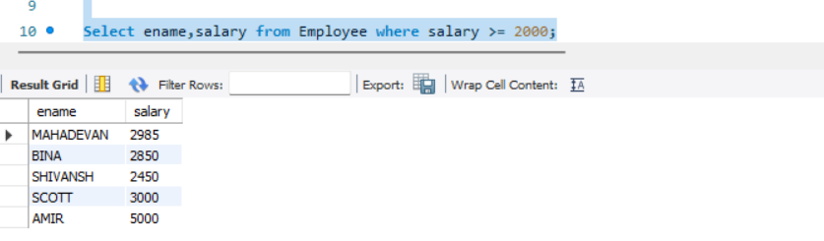

B. Display details of employee who are getting commissions

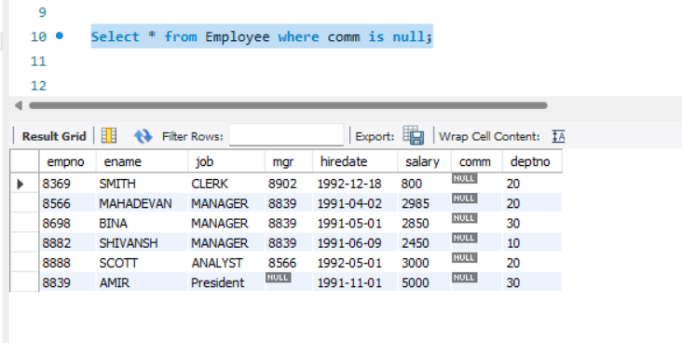

C. Display ename and salary of employee whose salary is not in range of 2500 and 4000

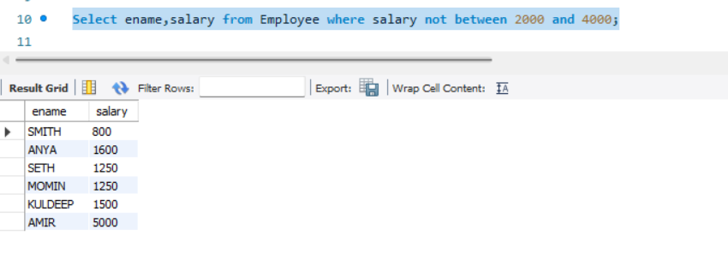

D. Display ename ,Job title and salary of employee who dont have manager

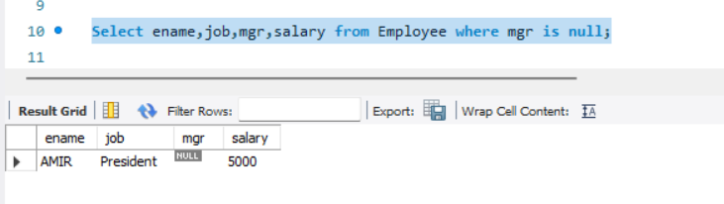

E. Display ename of employee who name contains ‘A’ as third alphabet

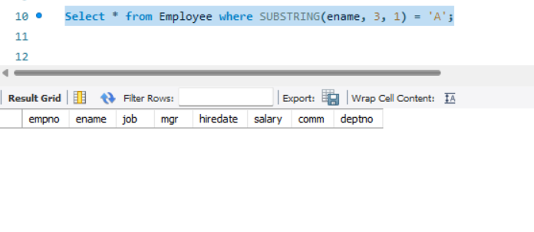

Ename contains ‘A’ as second alphabet

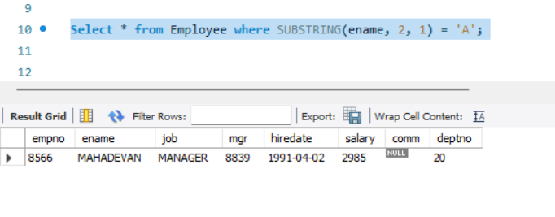

F. Display ename of employee who name contains ‘T’ as last alphabet

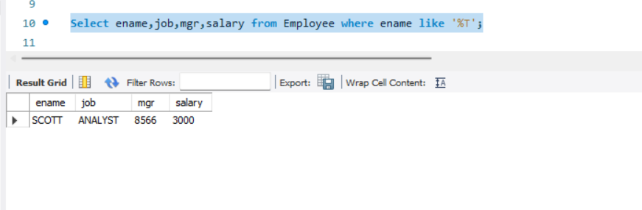

SQL queries used:

1. create table Employee (empno int not null,ename varchar(15),job varchar(15), mgr int,hiredate int ,salary int not null, comm int,deptno int not null);
2. insert into Employee (empno ,ename ,job , mgr ,hiredate ,salary , comm ,deptno) values(8839,'AMIR','President',null,'1991-11-01',5000.00,null,30);
3. Select * from Employee;
4. Select * from Employee where SUBSTRING(ename, 2, 1) = 'A';
5. Select * from Employee where ename like ‘%T’
6. Select * from Employee where salary>=2000;
7. Select * from Employee where salary not between 2000 and 4000;
8. Select * from Employee where mgr is null;
9. Select * from Employee where comm is null;

***************************************************************************************************

# 2.JDBC connection:

## Java program to connect DB:

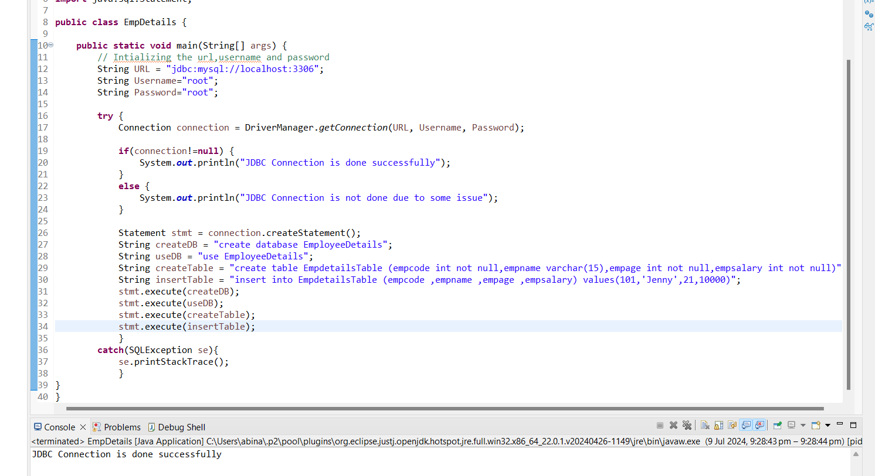

JDBC Connection is done successfully

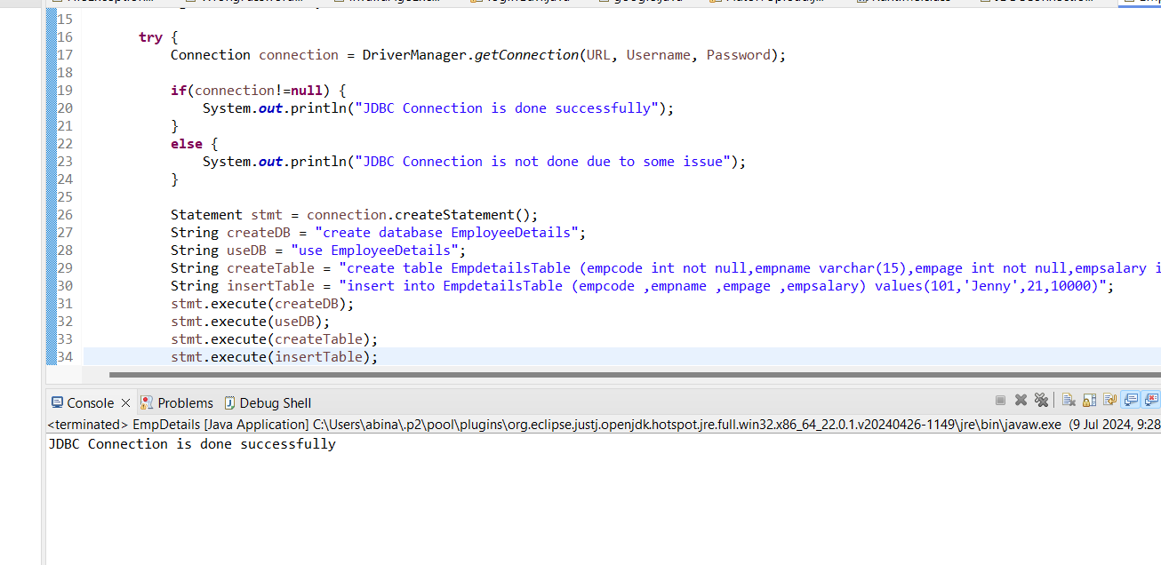

Check the newly created table in db:

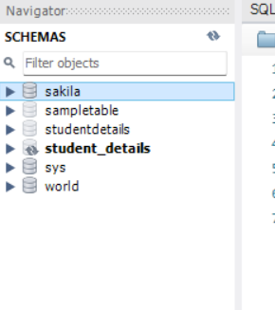

After refresh, newly created emp details db is shown

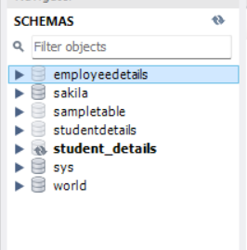

Table is created

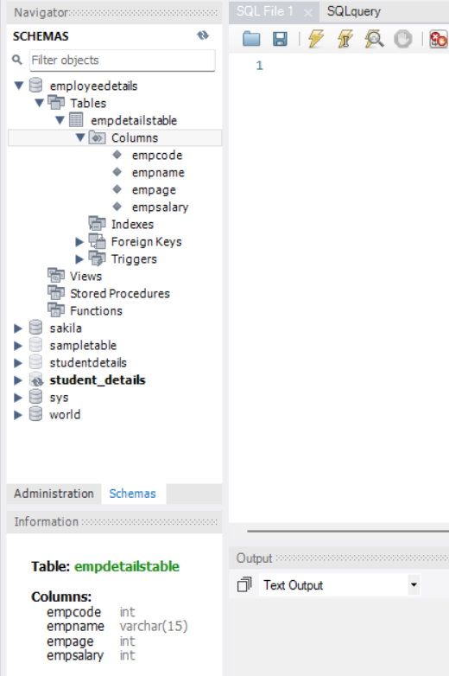

One row is inserted:

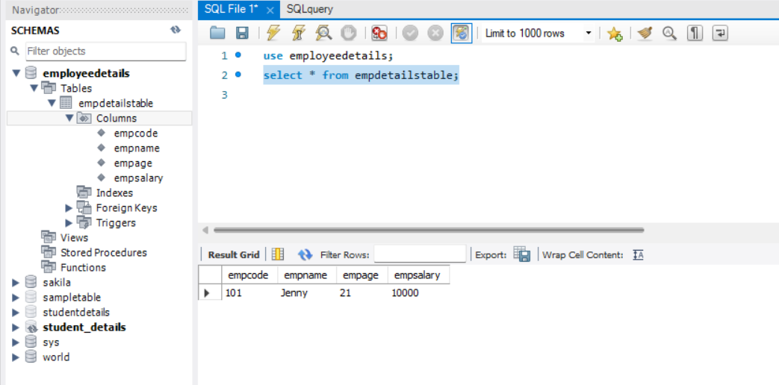

All other rows are inserted:

